Pinni Venkata Abhiram

20BAI1132

CSE3002 – Internet and Web Programming

Lab – 5

Form Elements – Radio Buttons

Question

Provide 3 options for the user of your elective courses and let the user select one option. In the event of the corresponding course, display the course name in upper case then provide the 3 color options and let the user select one color and display the text of the div tag with the chosen color.

Answer

HTML Code

<!DOCTYPE html>

<html lang="en">

<head>

    <meta charset="UTF-8">

    <meta http-equiv="X-UA-Compatible" content="IE=edge">

    <meta name="viewport" content="width=device-width, initial-scale=1.0">

    <title>JS stuff</title>

</head>

<body style="margin: 50px; border: 1px solid; padding: 40px; background-color: #D6E5FA; font-family: 'Lucida Sans', 'Lucida Sans Regular', 'Lucida Grande', 'Lucida Sans Unicode', Geneva, Verdana, sans-serif;">

    <h2><u>Internet and Web Programming</u></h2>

    <h3><u>Lab - 5 </u></h3>

    <br><br>

    <h3><u>Select Elective</u></h3>

    <input type="radio" name="elective" value="Business Analytics for Engineers "> Business Analytics

    <input type="radio" name="elective" value="International Business"> International B

    <input type="radio" name="elective" value="Personal Financial Management "> Personal Financial

    <br><br>

    <h3><u>Select Color</u></h3>

    <input type="radio" name="color" value="blue" onclick="function1()"> Blue

    <input type="radio" name="color" value="red" onclick="function1()"> Red

    <input type="radio" name="color" value="green" onclick="function1()"> Green

    <br><br>

    <div id = "rs"></div>

    <br><br>

    <button type="submit" onclick="function2()" style="width: 100px; height: 50px;">Refresh Page</button>

    <script src="index.js"></script>

</body>

</html>

JavaScript Code

function function1()

{

    var x = document.getElementsByName("elective");

    for (var i = 0 ; i < x.length ; i++)

    {

        if (x[i].checked)

        {

            var ans = (x[i].value).toUpperCase();

        }

    }

    var o = document.getElementsByName("color");

    for (var i = 0 ; i < o.length ; i++)

    {

        if (o[i].checked)

        {

            var ans2 = o[i].value;

            document.querySelector("#rs").style.color = ans2;

        }

    }

    document.querySelector("#rs").innerHTML = ans + " is chosen with the color " + ans2;

    document.querySelector("#rs").style.fontSize = "2rem"

}

function function2()

{

    location.reload();

}

Output

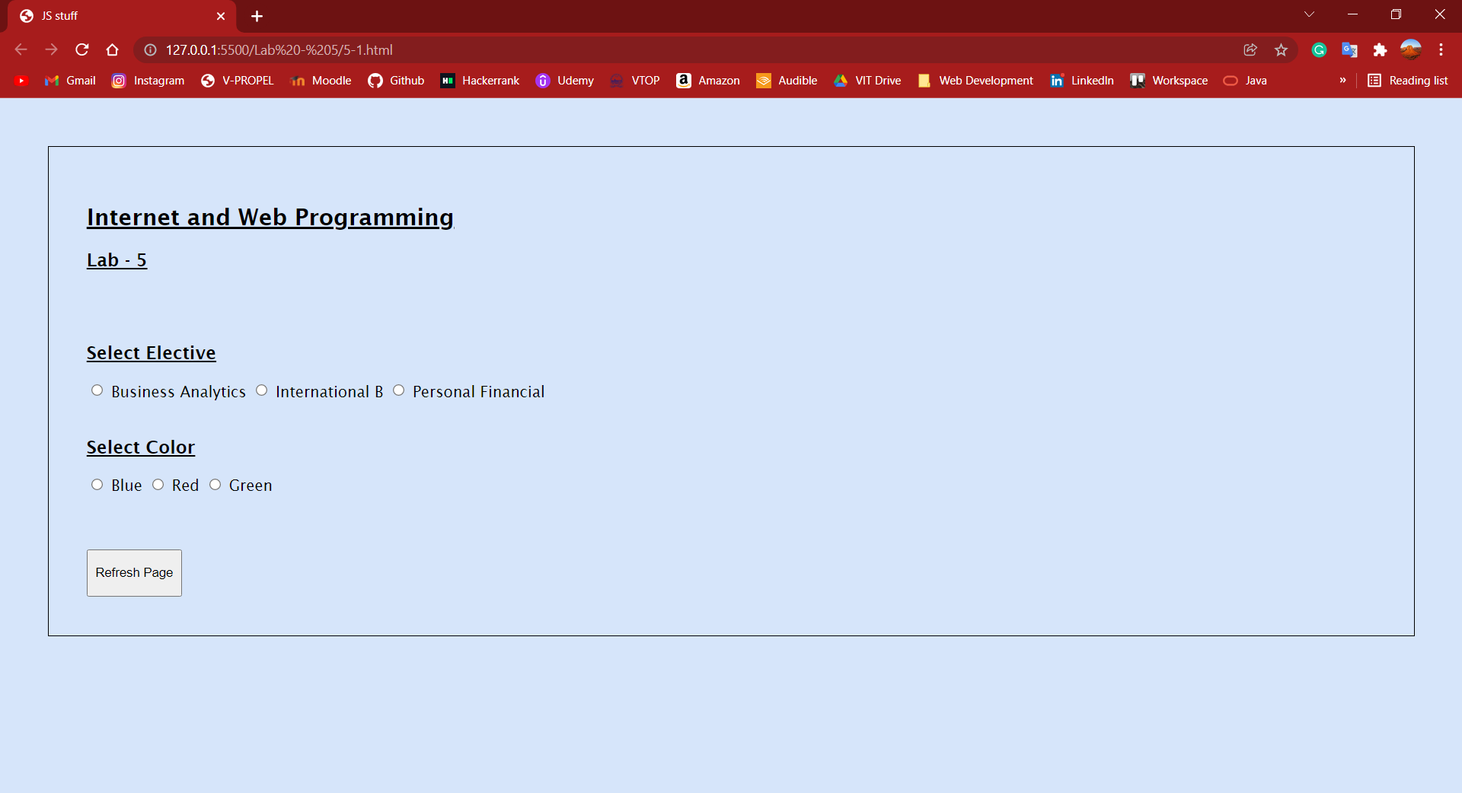

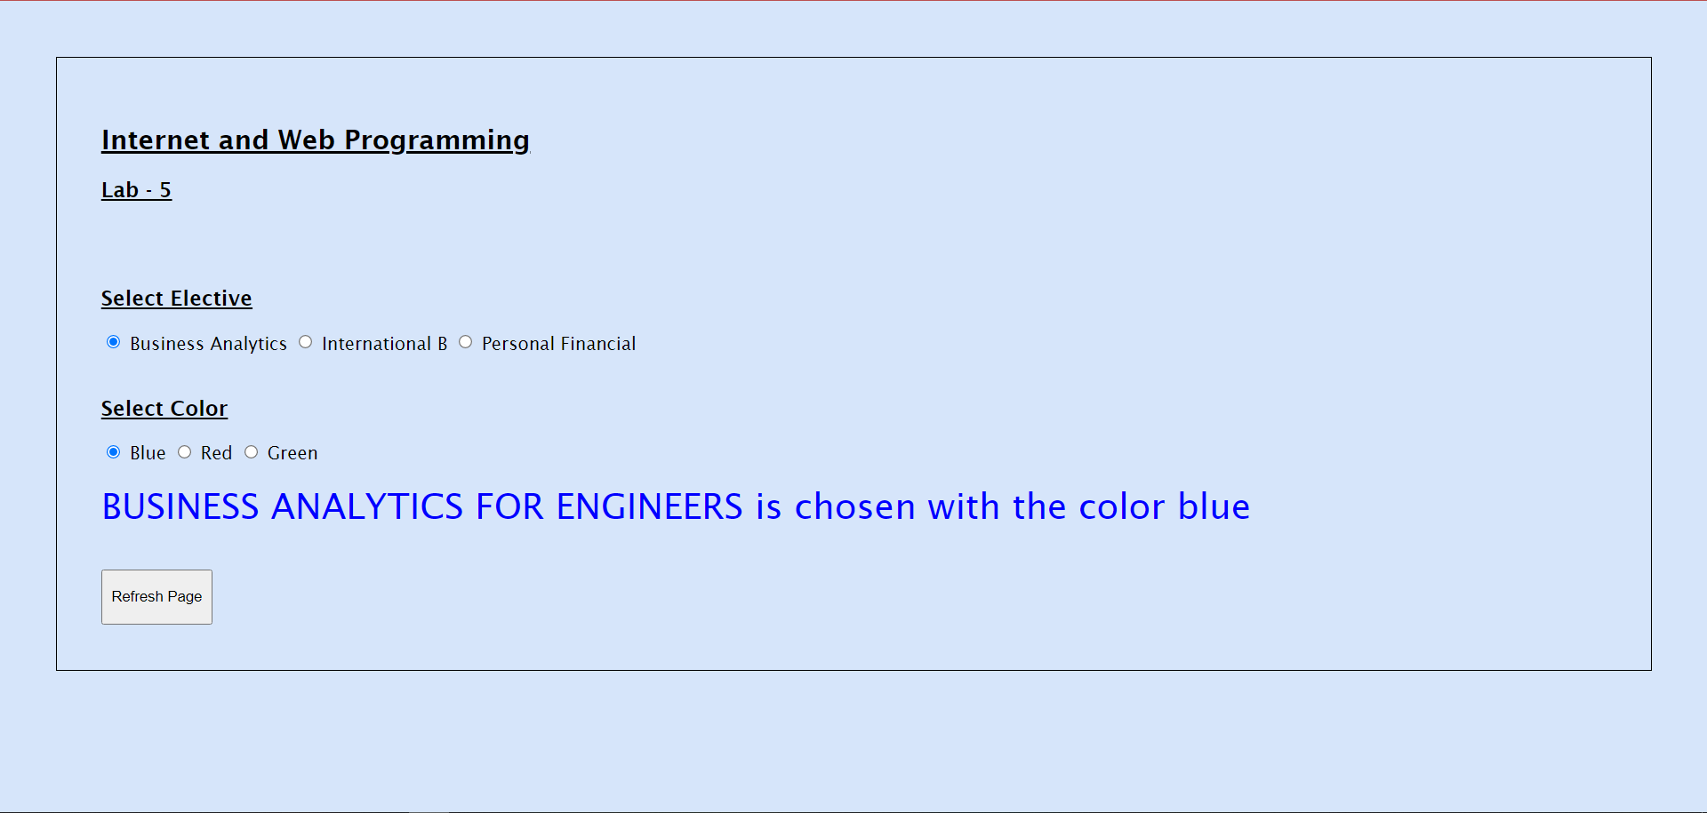

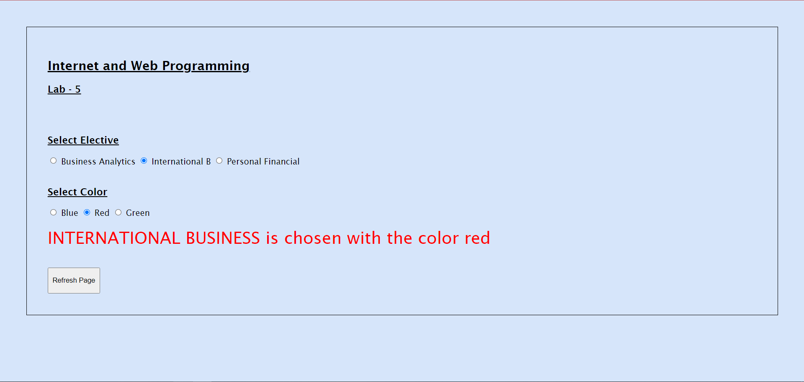

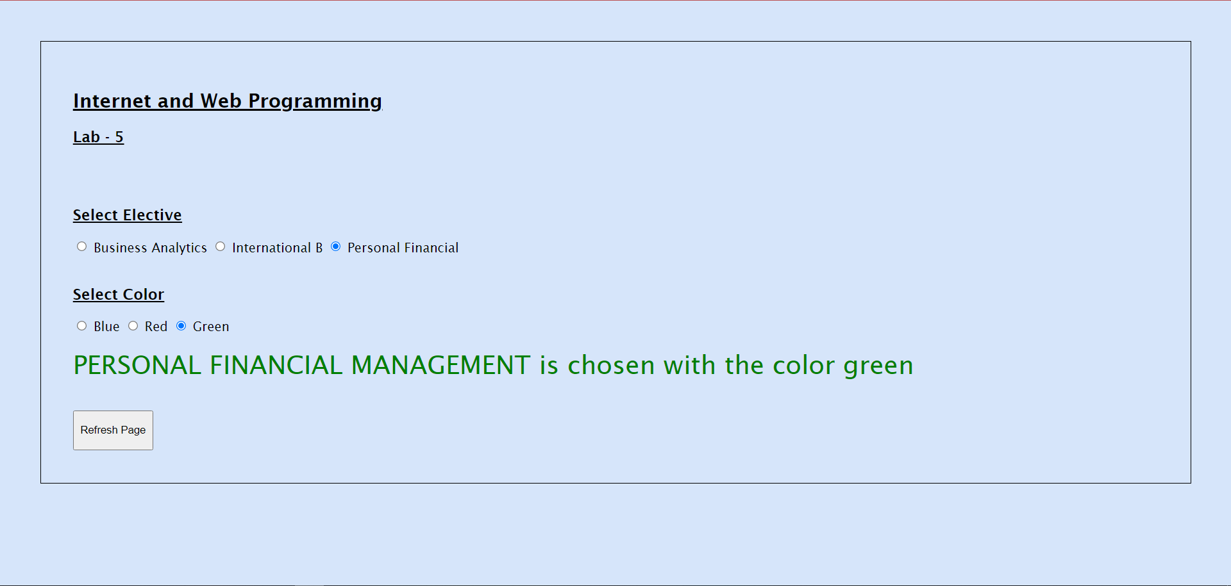

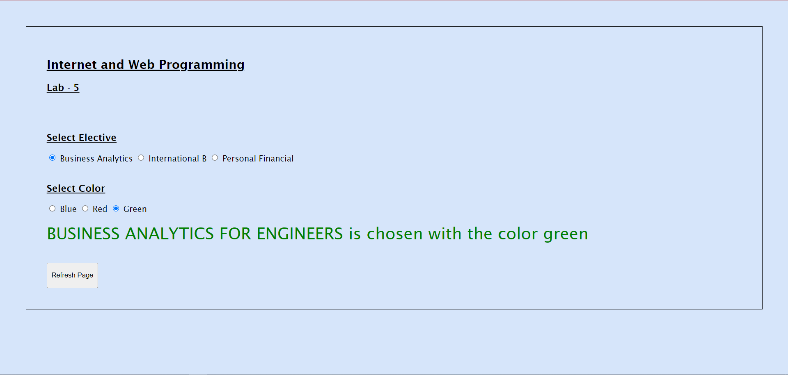

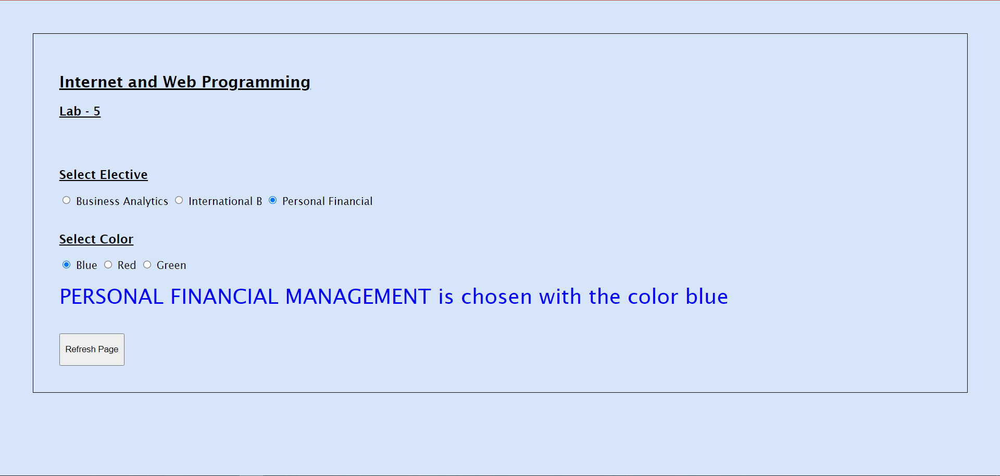

Thank you ma’am

Pinni Venkata Abhiram

20BAI1132